"Bayesian Space-Time Models for Expected Possession Added Value – Part 1 & 2" focus on a novel approach in hockey analytics. Part 1 introduces a Bayesian space-time model to calculate Possession Added Value (PAV), assessing players' decision-making during offensive sequences. It uses Bayesian methods for a nuanced analysis of spatial and temporal data. Part 2 builds on this by applying the PAV metric for team and individual player analysis, including a case study. These papers highlight the strengths of Bayesian models in handling complex data and suggest improvements for future sports analytics applications.

**Define the Problem**: The research aims to quantify the value of players' actions in hockey, specifically their influence on possession in the offensive zone.

**Summarize Key Points**: The authors introduce a Bayesian space-time model to calculate the Possession Added Value (PAV), a metric assessing players' decisions during offensive sequences.

**Compare Methods**: The approach is compared with existing models in sports analytics, using Bayesian methods for a nuanced analysis of spatial and temporal data.

**Numerical Examples/Codes**:  
A heat map of likely scenarios to happen cooler colors less likely results, darker colors more likely results.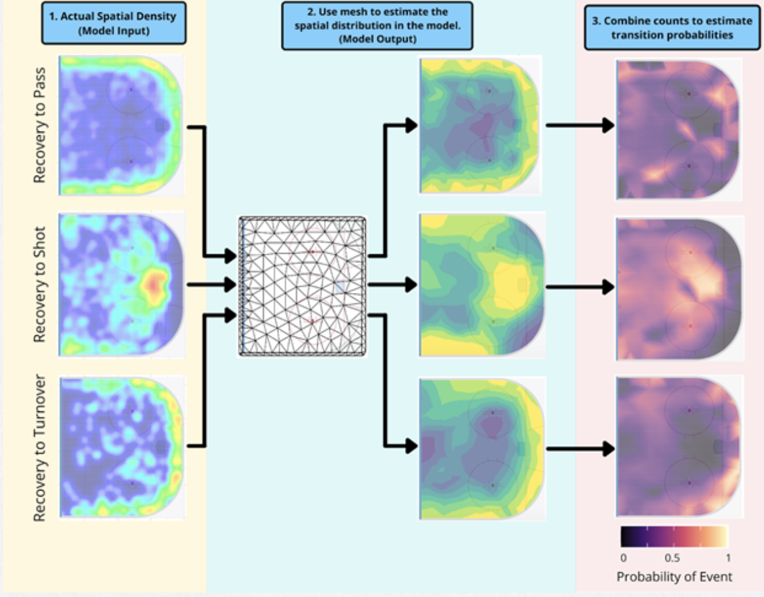

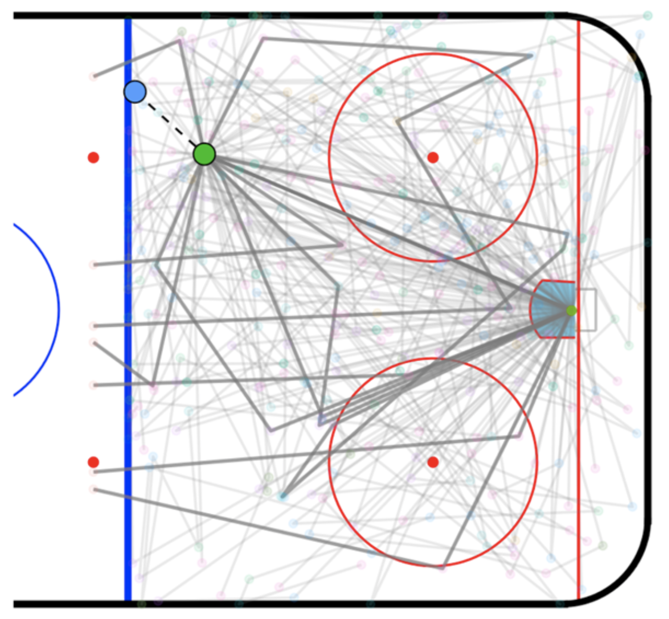  
Starting from the Blue Dot, a pass is attempted to the green dot. Darker lines are more likely probabilities, lighter lines less likely. They are attempting to score into the little rectangle at right center.

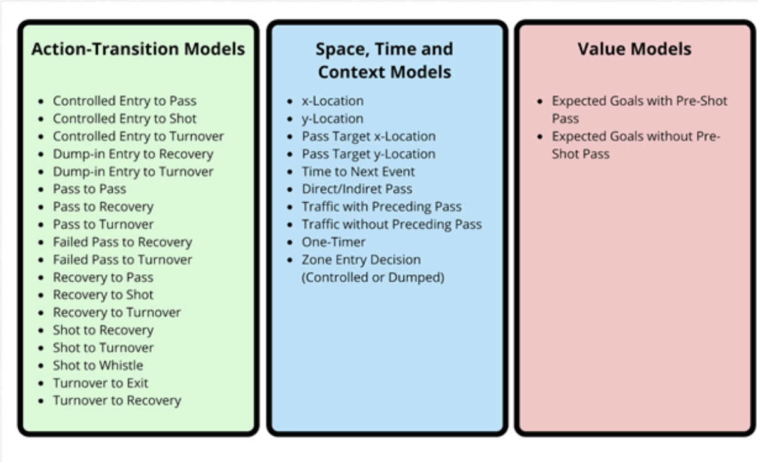Possible outcomes

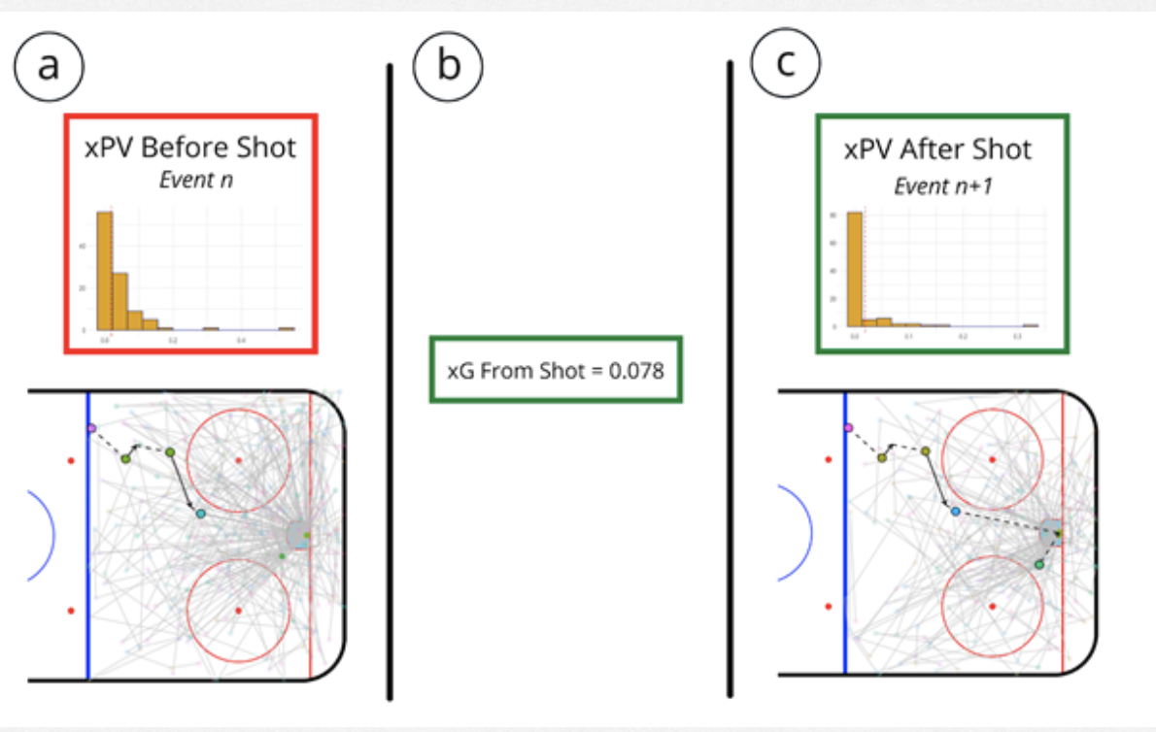

Before and After of xPV and xG calculations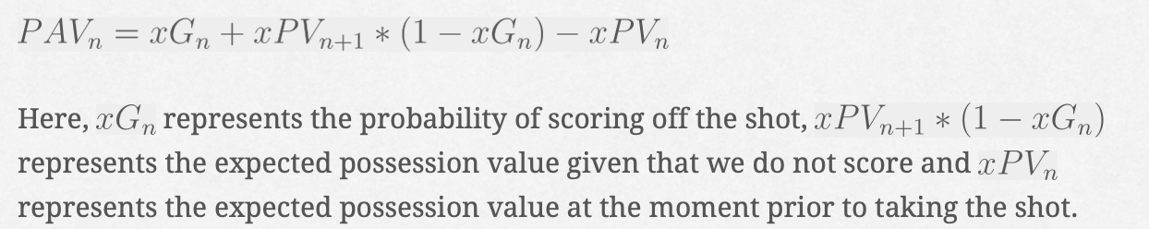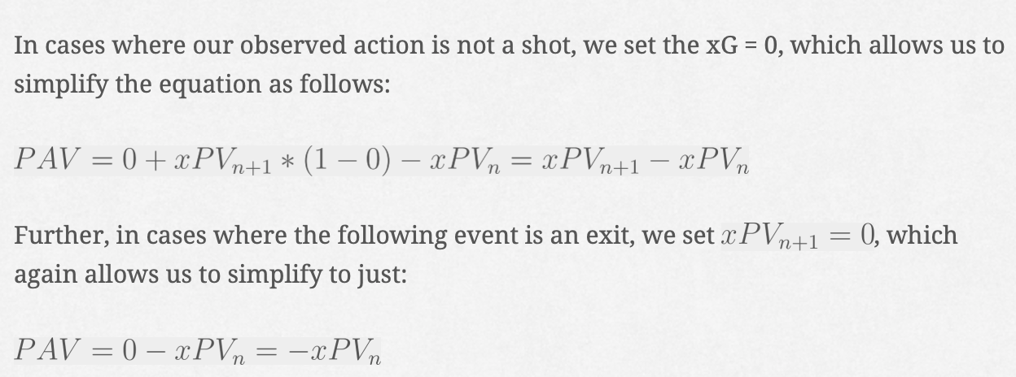  
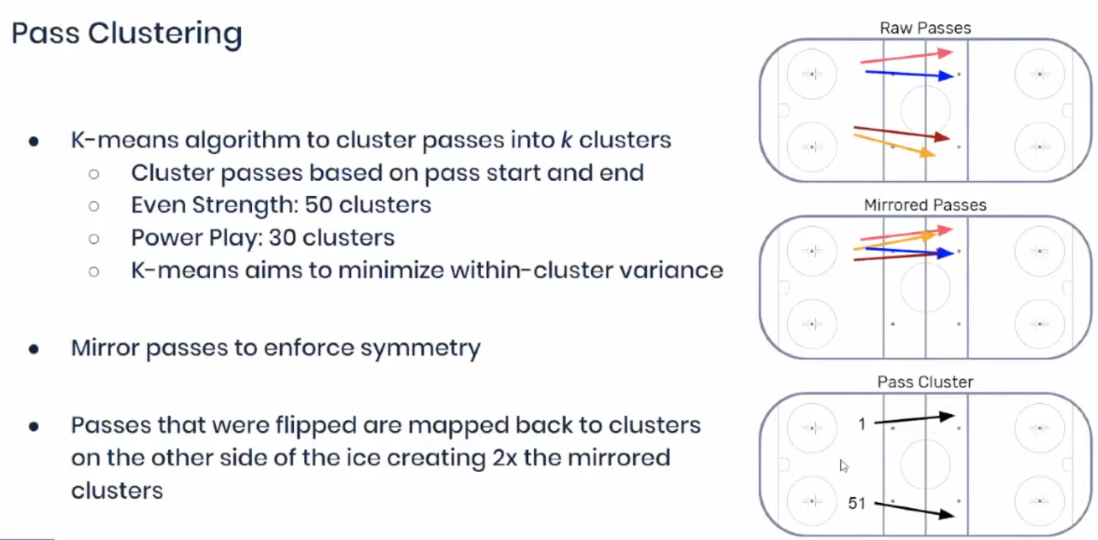

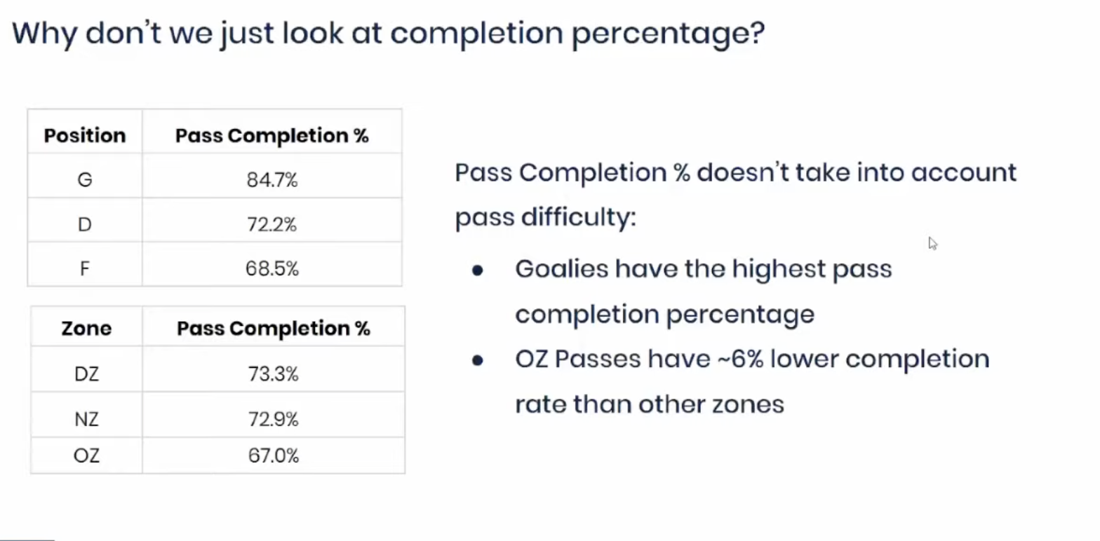

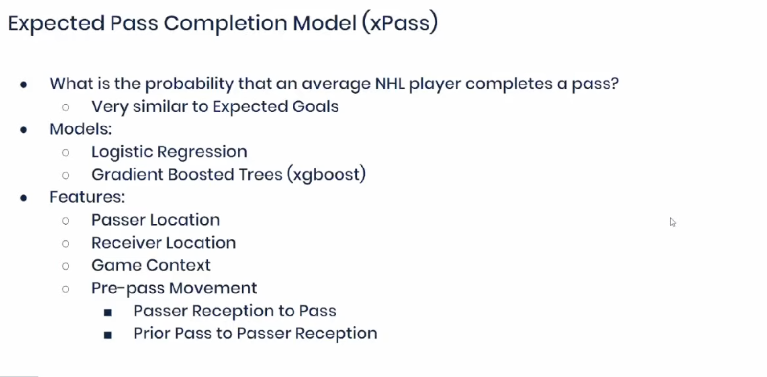

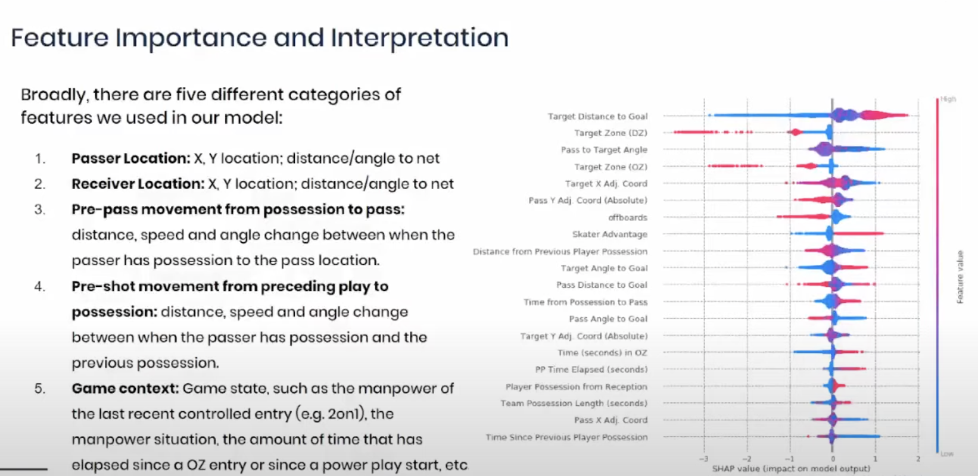

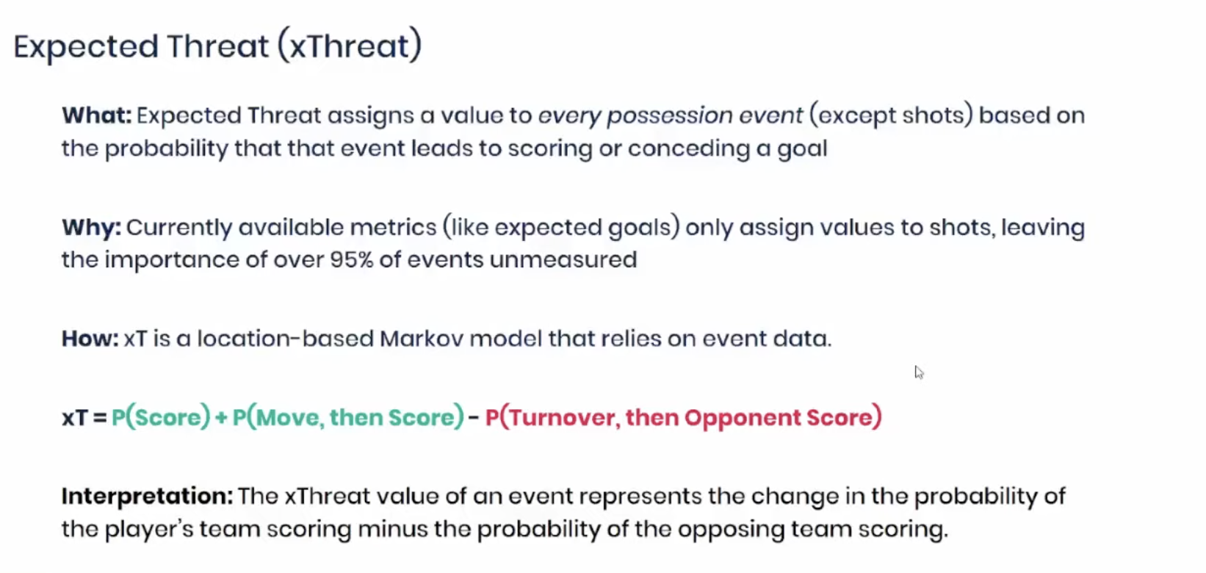

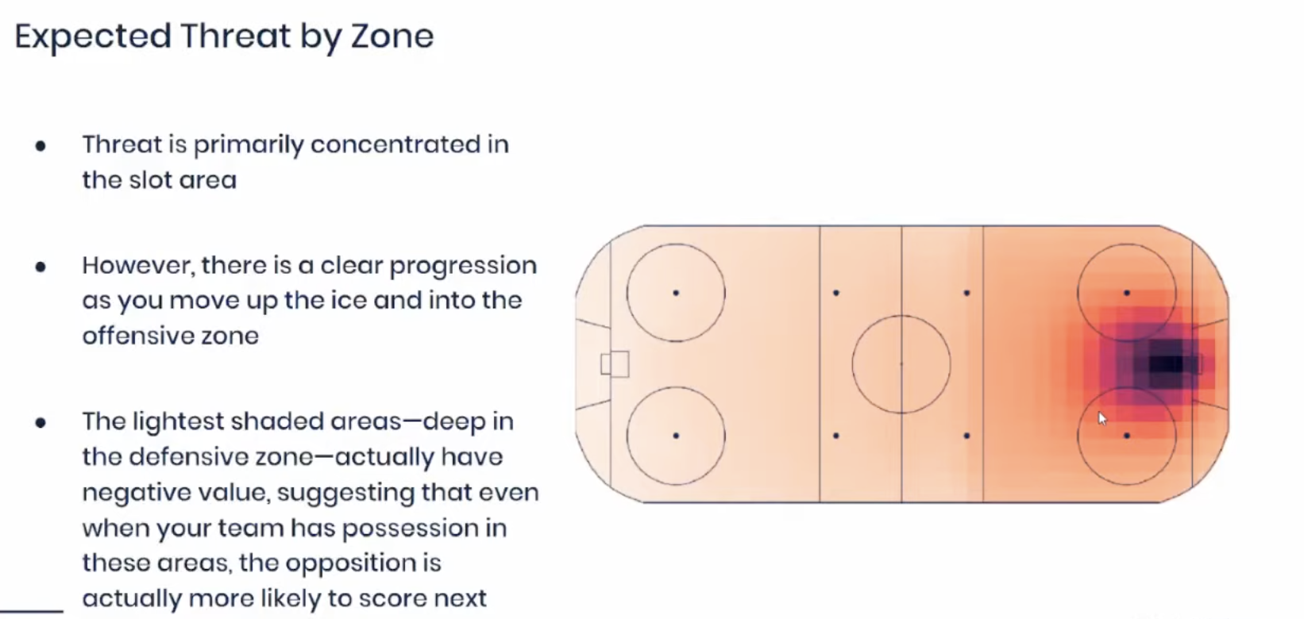

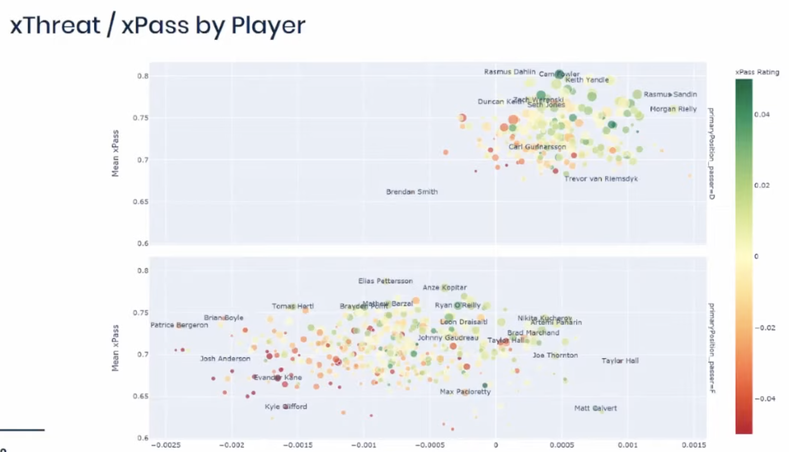A graph of every player of varying threat levels. In this case, you want players on your team who are in the green.

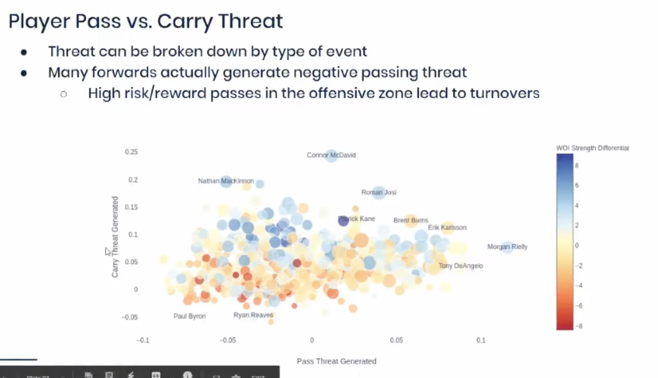

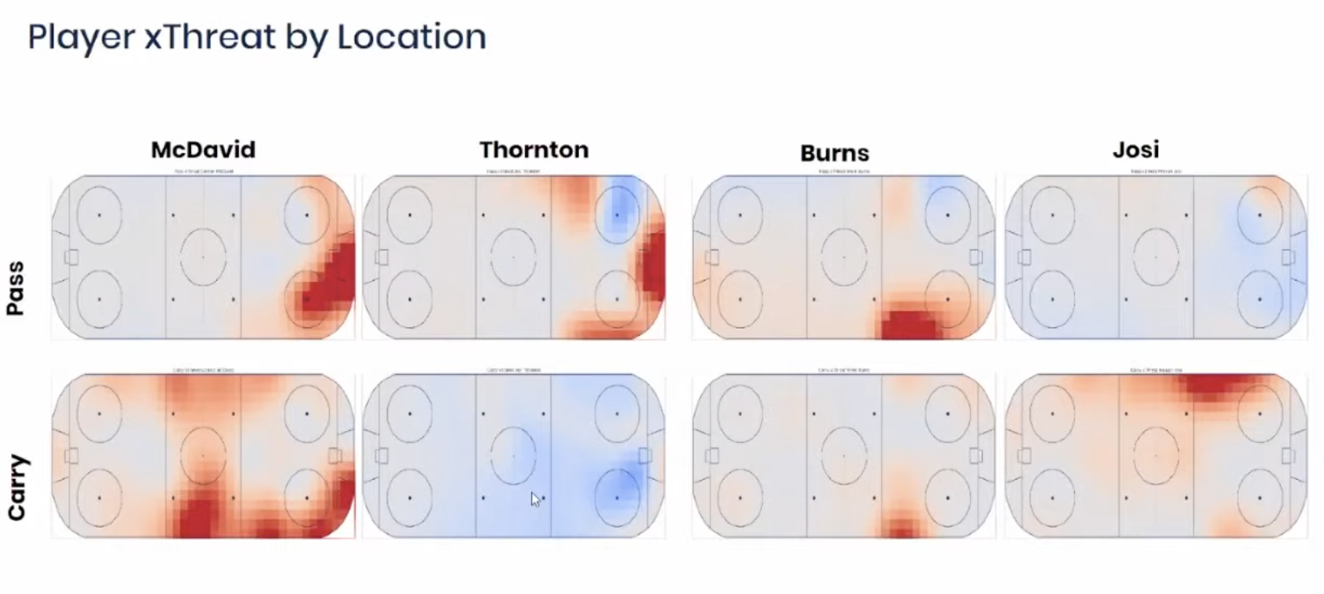Top of Rows are 4 different players, each performing a pass or carry(moving the puck). Your best player should be someone like Connor McDavid as a well rounded player, the other three players are a mix of being good on offense or defense.

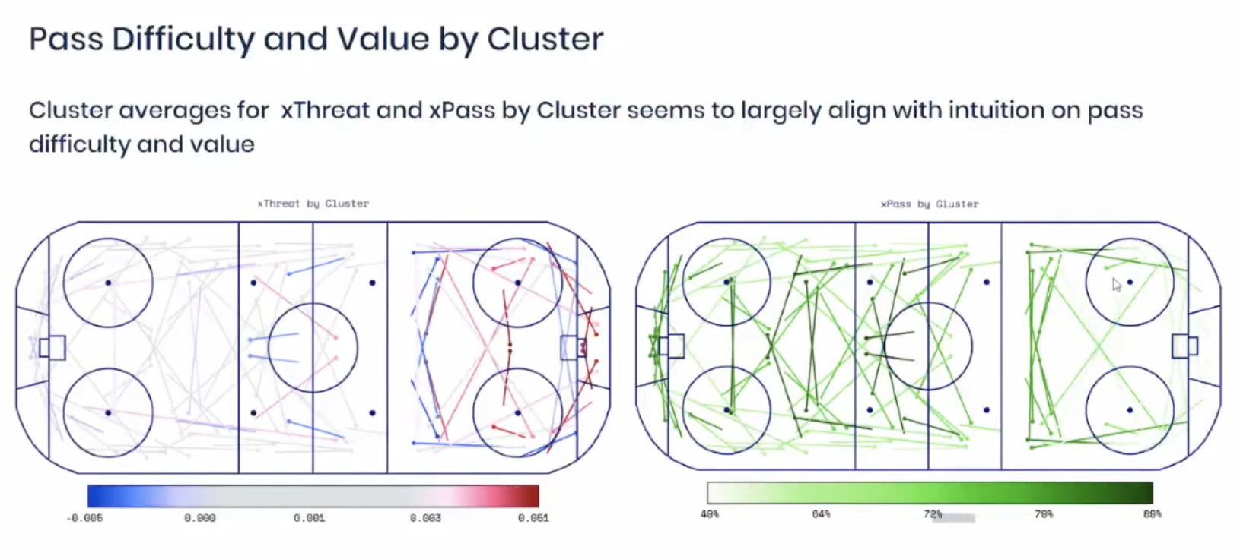

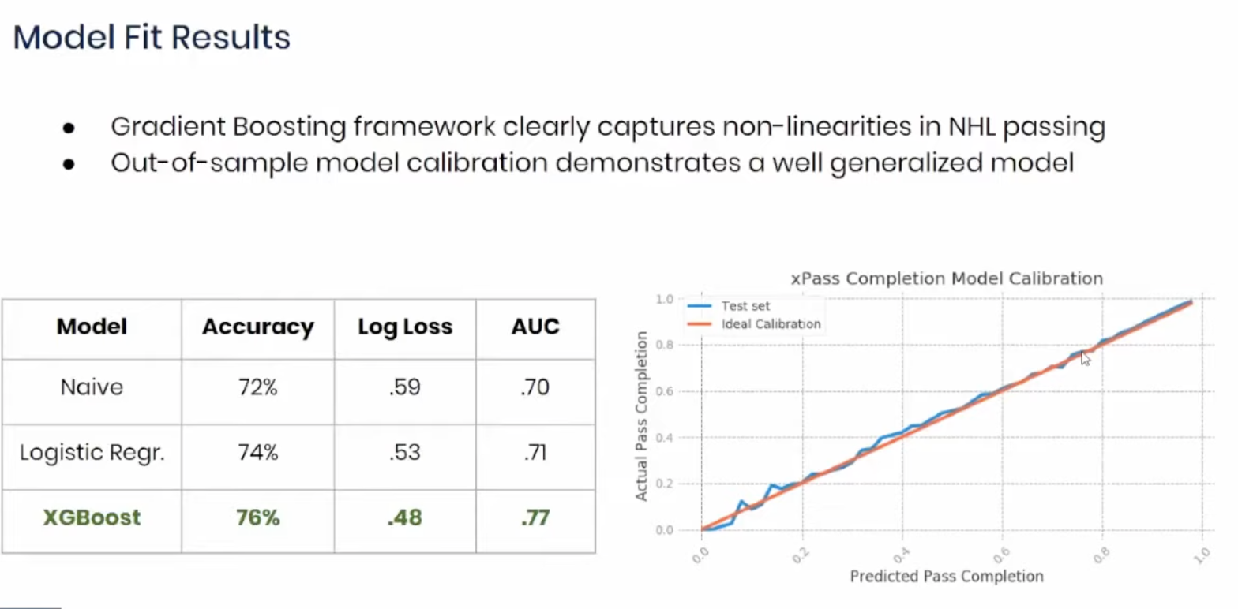

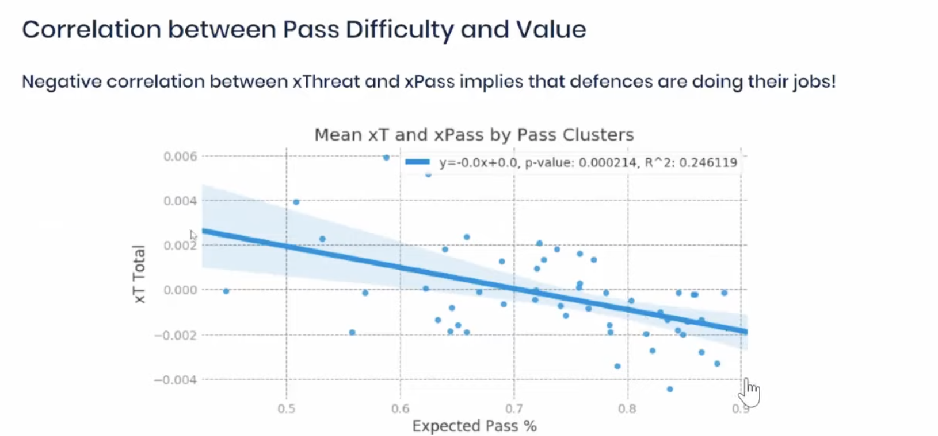

In this chart, the defense makes a concerted effort to force an offensive to make a pass. Higher expected pass percentage is great for the defense, possibly bad for offense

**Strengths and Limitations**: The strength lies in the model's sophisticated handling of space-time data. A limitation might be the complexity of the model, which could pose computational challenges.

**Improvement and Recommendation**: The papers suggest improvements in model differentiation between action types and recommend the use of PAV for detailed player and team analysis.

"Bayesian Statistics Meets Sports: A Comprehensive Review" by Edgar Santos-Fernandez, Paul Wu, and Kerrie L. Mengersen is an extensive review of the application of Bayesian methods in sports analytics. The review covers the rapid growth of Bayesian approaches due to their flexibility in modeling complex problems and accounting for uncertainty. It discusses various sports where these methods have been applied, particularly focusing on game outcome modeling and player performance evaluation. The review also addresses the growing volume of sports data and the availability of Bayesian computation software, contributing to the popularity of these methods in sports analytics.

**Define the Problem**: The review focuses on the increasing application of Bayesian methods in sports analytics, examining their development, popularity, sports applications, and challenges.

**Summarize Key Points**: Bayesian methods are noted for their advantages in handling complex problems, providing probabilistic estimates and predictions, combining information sources, and updating learning with new data. The review outlines the growth in sports analytics facilitated by these methods and the corresponding increase in relevant publications.

**Compare Methods**: The review categorizes the wide range of Bayesian methods applied in sports, including regression, hierarchical models, and spatial-temporal analysis. It does not aim to directly compare frequentist and Bayesian methods, but rather to showcase the developments and applications of the latter.

**Numerical Examples/Codes**: 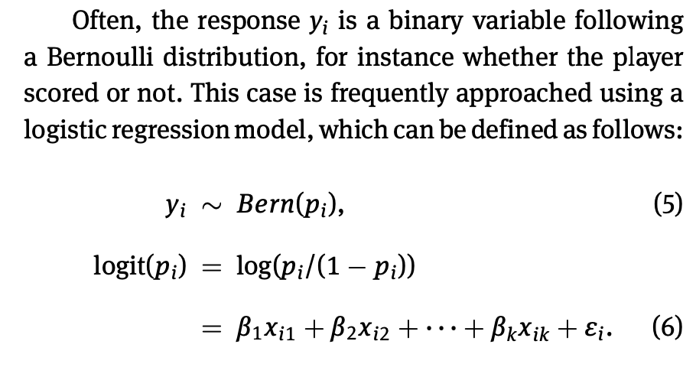

**Strengths and Limitations**: Strengths of Bayesian methods in sports analytics include flexibility, the ability to incorporate prior knowledge, and the provision of a probabilistic framework for predictions. Challenges or limitations might include computational complexity and the need for substantial data for model training and validation.

**Improvement and Recommendation**: The review implies that Bayesian methods have significantly improved the field of sports analytics by addressing complex problems and offering nuanced insights. It recommends the continued and expanded use of Bayesian methods to capture the multi-faceted nature of sports data.

James Kierans' thesis, "Isolation of Latent Player Shooting Ability in the National Hockey League," explores advanced statistical methods to assess NHL players' shooting talent. It emphasizes the importance of incorporating comprehensive data, including pre-shot movement, to reduce biases in traditional shooting metrics. The thesis uses logistic regression and empirical Bayesian analysis to isolate players' impact on shot quality, aiming to provide a more accurate measurement of individual shooting skills. The research highlights the complexities in quantifying such skills and suggests potential directions for further study in sports analytics.

**Define the Problem**: The thesis investigates the ability to predict a player's shooting talent in the NHL using shot quality models, with a focus on addressing biases present in publicly available data by incorporating pre-shot movement data.

**Summarize Key Points**: The study uses public NHL data and a privately tracked dataset with pre-shot movement information. It explores how the inclusion of this additional data affects the analysis and prediction of player shooting talent.

**Compare Methods**: The thesis compares traditional statistical methods with machine learning algorithms, such as logistic regression and empirical Bayesian analysis, for evaluating player performance based on shooting data.

**Numerical Examples/Codes**: This is the player’s performance data according to Bayes’ theorem

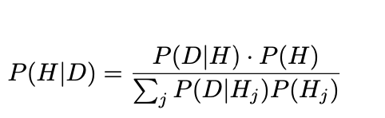

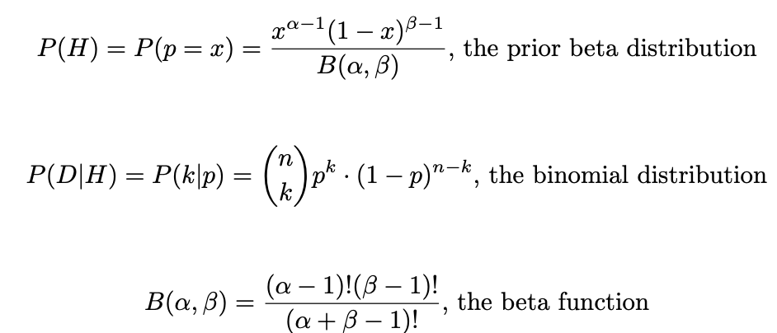

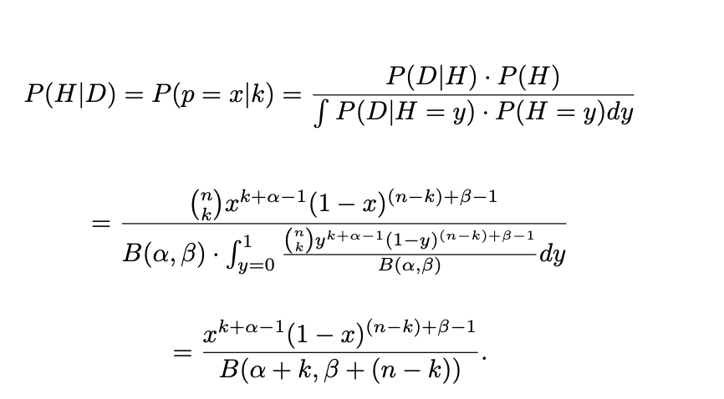

**Strengths and Limitations**: Strengths include the novel approach of incorporating pre-shot movement data to reduce bias in shot quality evaluations. Limitations might include the complexity of the models and the potential challenge in obtaining comprehensive pre-shot movement data.

**Improvement and Recommendation**: The thesis recommends using advanced statistical models that account for previously unconsidered factors (like pre-shot movement) in player evaluation. It suggests that further research with more detailed data could provide even deeper insights into player performance.

"A Bayesian Approach to Predict the Number of Goals in Hockey" is an academic paper that employs Bayesian statistical methods to forecast the number of goals in hockey matches. This approach includes considering various factors such as previous game performance and home advantage. The paper demonstrates how Bayesian methods can be utilized to improve predictions in sports, particularly in a sport like hockey where predicting outcomes can be quite challenging. The paper is a notable example of applying advanced statistical techniques to sports analytics.

**Problem Definition**: Developing a predictive model for the number of goals in a hockey match using Bayesian methodology.

**Summary of Key Points**: The study employs different models considering factors like previous game points, home advantage, and expert opinions.

**Comparison of Methods**: Bayesian predictive models are compared, with a focus on addressing the infrequent nature of goals in hockey.

**Numerical Examples/Codes**: Models are applied to predict the number of goals, including error analysis for each model.

Bayesian Prior and Posterior Predictive Density Estimations

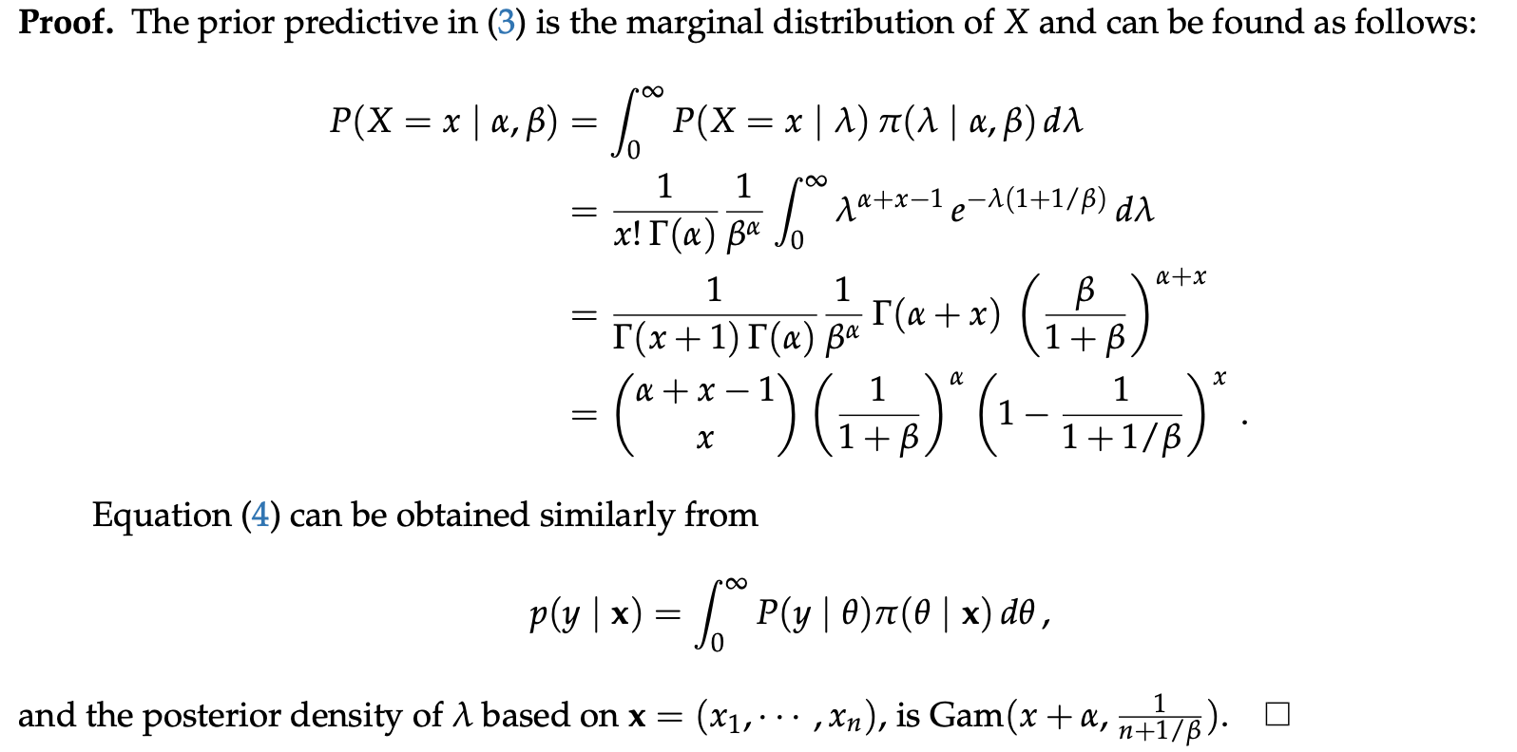

**Strengths and Limitations**: Strengths include the incorporation of expert opinions and previous game data; limitations might relate to the model's predictive accuracy.

**Improvements and Recommendations**: The study suggests that Bayesian models, enriched with diverse data sources, can enhance the prediction of game outcomes in hockey.   
  
**Conclusion**  
  
These articles helped me provide an insightful examination of Bayesian approaches in ice hockey analytics. It underscores the advantages of Bayesian models in effectively handling complex space-time data, which is crucial in capturing the dynamic nature of hockey. However, the complexity of these models poses computational challenges. Future recommendations include enhancing the differentiation between action types in the models and continuing to leverage Possession Added Value (PAV) for detailed player and team analysis. In addition, providing enhanceddata collection and developing more comprehensive datasets, including granular details such as player positions, puck trajectories, and in-game strategies, can significantly enhance the predictive accuracy of Bayesian models in hockey analytics. Also, implementing Bayesian models that can provide real-time insights during games could greatly benefit coaching strategies and in-game decision-making, elevating the practical application of these analytical methods in professional hockey. These improvements could lead to more precise and actionable insights in the field of hockey analytics.

What fascinates me is we can now quantify certain intangibles about a player. When we say, “How does a player see everything or make seemingly complex decisions without hesitation,” we have metrics that can confirm what our eyes see. The clutch gene or saying a player “has it (whatever it is)” is no longer indeterminable, but a true function of the players’ skills. This will make for greater storytelling in the future and bring an audience to understanding the game at a much higher and enriching level.

Articles / References

Kumagai, B., Nahabedian, M., Châtel, T., & Stokes, T. (2021). “Bayesian Space-Time Models for Expected Possession added Value – Part 1 of 2.” [https://hockey-graphs.com/]​​.

Kumagai, B., Nahabedian, M., Châtel, T., & Stokes, T. (2021). “Bayesian Space-Time Models for Expected Possession added Value – Part 2 of 2.” [https://hockey-graphs.com/]​​.

Santos-Fernandez, Edgar, Wu, Paul and Mengersen, Kerrie L.. "Bayesian statistics meets sports: a comprehensive review" *Journal of Quantitative Analysis in Sports*, vol. 15, no. 4, 2019, pp. 289-312. [https://doi.org/10.1515/jqas-2018-0106].

Sadeghkhani, A., & Ahmed, S. E. (2019). “A Bayesian Approach to Predict the Number of Goals in Hockey.” [Brock University, Canada]​​.

Kierans, J. (2021). ”Isolation of Latent Player Shooting Ability in the National Hockey League.” [Concordia University, Canada]​​.  
  
Graphics and Charts:

WHKYAC. May 9, 2020. ISOLHAC - SESSION3  
David Yu with Sam Forstner / NHL passing Analysis https://www.youtube.com/watch?v=Q-kWb6Vshmo